**Directions:** Use the information provided in the table and the pictures of the organisms to construct a food web. Draw arrows to show the direction of energy transfer from organism to organism. When you are finished, use your food web to complete the last column of the vocabulary chart and answer the questions below.

|  |  |
| --- | --- |
| **ANIMAL** | **WHAT IT EATS** |
| Earthworm | dead plants and animals (detritus) |
| Soil Bacteria | dead plants and animals (returns nutrients to the environment) |
| Detritus | n/a |
| Stink Beetle | leaves/grasses |
| Monarch Butterfly | leaves(as a caterpillar), nectar |
| Broad-Tailed Hummingbird | nectar |
| Western Meadowlark | insects, earthworms, seeds |
| Snowshoe Hare | leaves/grasses, flowers, berries, shrubs |
| Pocket Mouse | insects, seeds |
| Deer Mouse | seeds/nuts, berries, leaves/grasses, insects |
| Ground Squirrel | leaves/grasses, seeds/nuts, berries, insects |
| Raccoon | fruits, nuts, grass, insects, bird eggs |
| Spotted Skunk | mice, bird eggs, insects, grasses, berries |
| Mule Deer | shrubs, twigs, grasses |
| Bull Snake | ground squirrels, mice |
| Rattlesnake | ground squirrels, mice |
| Bison | grasses |
| Elk | grasses, twigs, berries |
| Wolf | elk, mule deer, bison |
| Coyote | scavenger: will eat almost anything animal or vegetable; prefers rodents, rabbits |

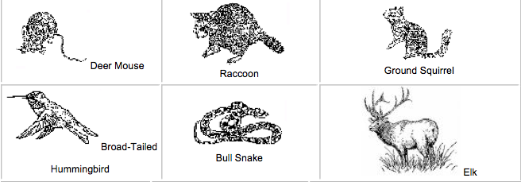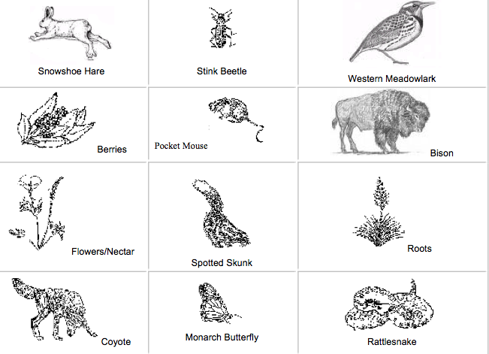

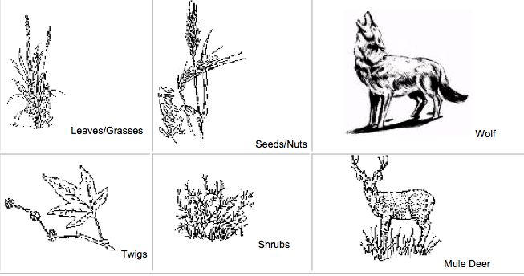

Detritus

Soil Bacteria

Earthworm

